**IOT BASED SMART CROP PROTECTION SYSTEM FOR AGRICULTURE**

**Category:INTERNETOFTHINGS**

APROJECTREPORT

***Submittedby***

**Iswariya A**

**Jusmitha J S**

**Roshni P S**

**Ebsiba L C**

***FROM***

**BETHLAHEM INSITUTE OF ENGINEERING**

***InfulfillmentofprojectinIBM-NALAYATHIRAN2022TeamId:PNT2022TMID51290***

## PROJECTGUIDES

**IndustryMentor: Mr. Dinesh**

#### FacultyMentor:Mrs. Henilin J K

## INDEX

* 1. **INTRODUCTION**
     1. Project Overview
     2. Purpose
  2. **LITERATURE SURVEY**

**1.** Existing problem

* + 1. Problem Statement Definition
    2. **IDEATION & PROPOSED SOLUTION**
       1. Empathy Map Canvas
       2. Ideation & Brainstorming
       3. Proposed Solution
       4. Problem Solution fit
    3. **REQUIREMENT ANALYSIS**
       1. Functional requirement

2 Non-Functional requirements

* + 1. **PROJECT DESIGN**
       1. Data Flow Diagrams
       2. Solution & Technical Architecture
    2. **PROJECT PLANNING & SCHEDULING**
       1. Sprint Planning & Estimation
       2. Sprint Delivery Schedule
    3. **CODING & SOLUTIONING (Explain the features added in the project along with code)**
       1. Features
       2. Codes
    4. **TESTING**
       1. User Acceptance Testing
    5. **RESULT**
       1. Performance Metrics
    6. **ADVANTAGES & DISADVANTAGES 11.CONCLUSION**

1. **FUTURE SCOPE**
2. **APPENDIX**

Source code GitHub Link

# INTRODUCTION

## Project overview

* + - The device will detect the animals and birds using the Clarifai service.
    - If any animal or bird is detected the image will be captured and stored in the IBM Cloud object storage.
    - It also generates an alarm and avoid animals from destroying the crop .
    - The image URL will be stored in the IBM Cloudant DB service.
    - The device will also monitor the soil moisture levels, temperature, and humidity values and send them to the IBM IoT Platform.
    - The image will be retrieved from Object storage and displayed in the web application.
    - A web application is developed to visualize the soil moisture, temperature, and humidity values .
    - Users can also control the motors through web application.

## PURPOSE

An intelligent crop protection system helps the farmers in protecting the crop from the animals and birds which destroy the crop. This system also helps farmers to monitor the soil moisture levels in the field and also the temperature and humidity values near the field. The motors and sprinklers in the field can be controlled using the mobile application.

#### LITERATURE SURVEY

* 1. **Existing Problem**

Most of the farmers are facing many problems nowadays due to many reasons.

Our problem to solve is the invasion of various species such as birds and animals that harm the crops that are being cultivated. Various types of species such as birds and animals come to the cultivation field according to the crop that is being cultivated and also according to the season of cultivation. Some wild animals enter the field during night times when the field is near a forest region or when the farm cultivates some fruits and other crops that attract animals. Some animals cross the field in search of food and water and also the birds enter the field for food and they damage all the crops. When the animals enter the field they not only eat food but they also damage the entire field by walking upon the crops and also by spoiling the food crops. The birds, by entering the field they come to eat seeds of the crops and also they tend to drag the crops and ruin the entire field. Some birds enter the field to eat the insects and pests in the field.

## Problem Statement Definition

Most of the farmers are facing many problems nowadays due to many reasons. Our problem to solve is the invasion of various species such as birds and animals that harm the crops that are being cultivated. Various types of species such as birds and animals come to the cultivation field according to the crop that is being cultivated and also according to the season of cultivation. Some wild animals enter the field during night times when the field is near a forest region or when the farm cultivates some fruits and other crops that attract animals.

1. **IDEATION & PROPOSED SOLUTION**

#### Empathy Map Canvas

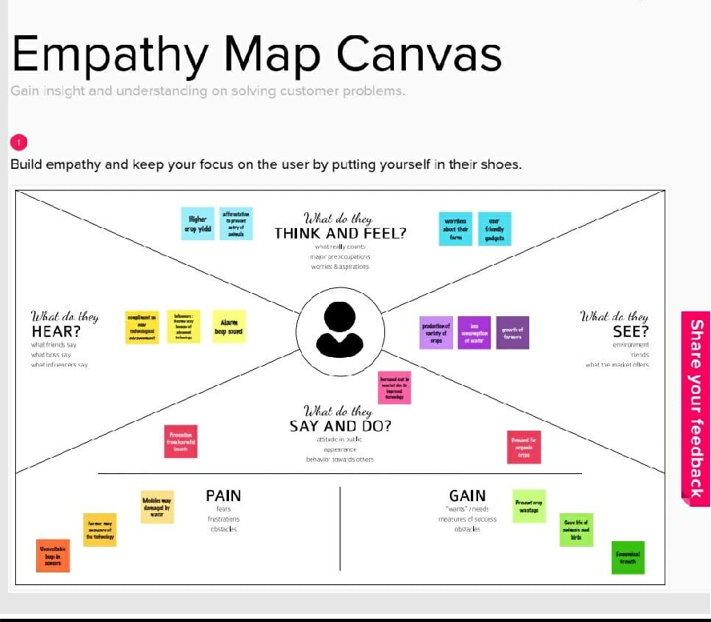

* 1. **Ideation and Brainstorming**

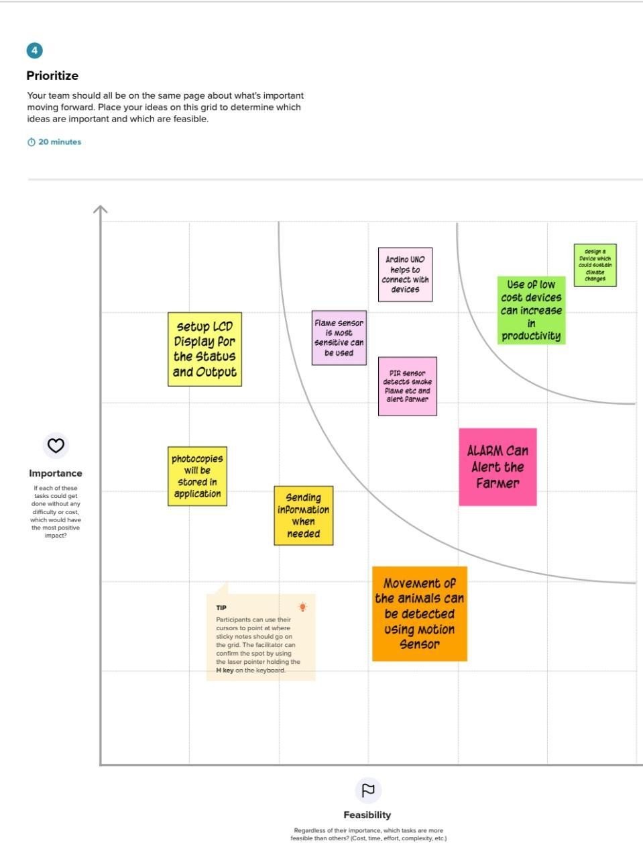

* 1. Proposed Solution

|  |  |  |
| --- | --- | --- |
| S.No | Parameter | Description |
| 1. | * Problem Statement (Problem to be solved) | * Crops are not irrigated properly due to insufficient labour forces. * Improper maintenance of crops against various environmental factors such as temperature climate, topography and soil quality which results in crop destruction. * Requires protecting crops from Wild animals attacks, birds and pests. |
| 2. | * Idea / Solution description | * Moisture sensor is interfaced with Arduino Microcontroller to measure the moisture level in soil and relay is used to turn ON and OFF the motor pump for managing the excess water level. It will be updated to authorities through IOT. * Temperature sensor connected to microcontroller is used to monitor the temperature in the field. * Image processing techniques with IOT is followed for crop protection against animal attacks. |
| 3. | Novelty / Uniqueness | * Automatic crop maintenance and protection using embedded and IOT technology. |
| 4. | Social Impact / Customer Satisfaction | * This proposed system provides many facilities which helps the farmers to maintain the crop field without much loss. |
| 5. | Business Model (Revenue Model) | * This prototype can be developed as product with minimum cost with high performance . |
| 6. | Scalability of the Solution | * This can be developed to a scalable product by using sensors and transmitting the data through Wireless Sensor Network and Analysing the data in cloud and operations is performed using robots . |

* 1. Problem Solution Fit

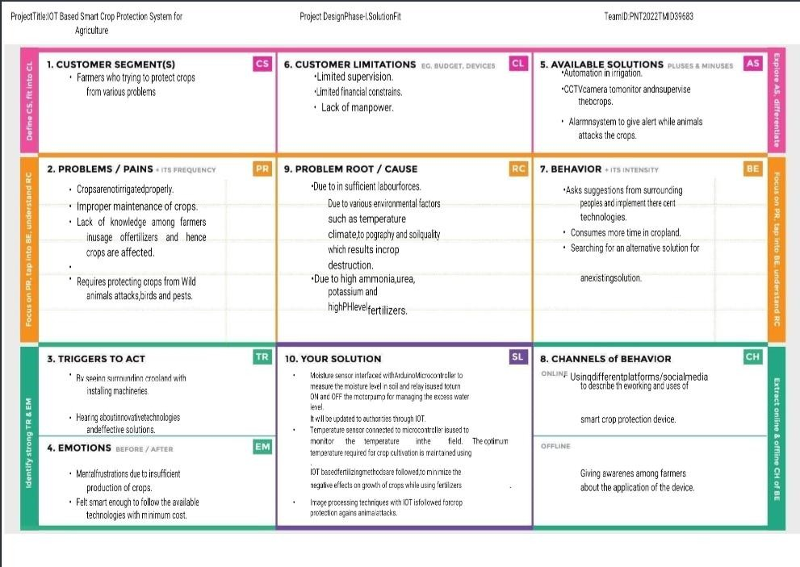

# REQUIREMENT ANALYSIS

### Functional Requirement

Following are the functional requirements of the proposed solution.

* FR-1 User Registration,Registration through Form Registration through Gmail Registration through LinkedIN
* FR-2 User Confirmation ,Confirmation via Email Confirmation via OTP
* FR-3 Tracking Expense Helpful insights about money management
* FR-4 Alert Message Give alert mail if the amount exceeds the budget limit
* FR-5 Category This application shall allow users to add categories of their expenses

### Non Functional requirement

Following are the non-functional requirements of the proposed solution.

* NFR-1 Usability You will able to allocate money to different priorities and also help you to cut down on unnecessary spending
* NFR-2 Security More security of the customer data and bank account details.
* NFR-3 Reliability Used to manage his/her expense so that the user is the path of financial stability. It is categorized by week, month, and year and also helps to see more expenses made. Helps to define their own categories.
* NFR-4 Performance The types of expense are categories along with an option

.Throughput of the system is increased due to light weight database support.

* NFR-5 Availability Able to track business expense and monitor important for maintaining healthy cash flow. NFR-6 Scalability The ability to appropriately handle increasing demands.

1. PROJECT DESIGN

#### Data Flow Diagrams

A Data Flow Diagram (DFD) is a traditional visual representation of the information flows within a system. A neat and clear DFD can depict the right amount of the system requirement graphically. It shows how data enters and leaves the system, what changes the information, and where data is store.

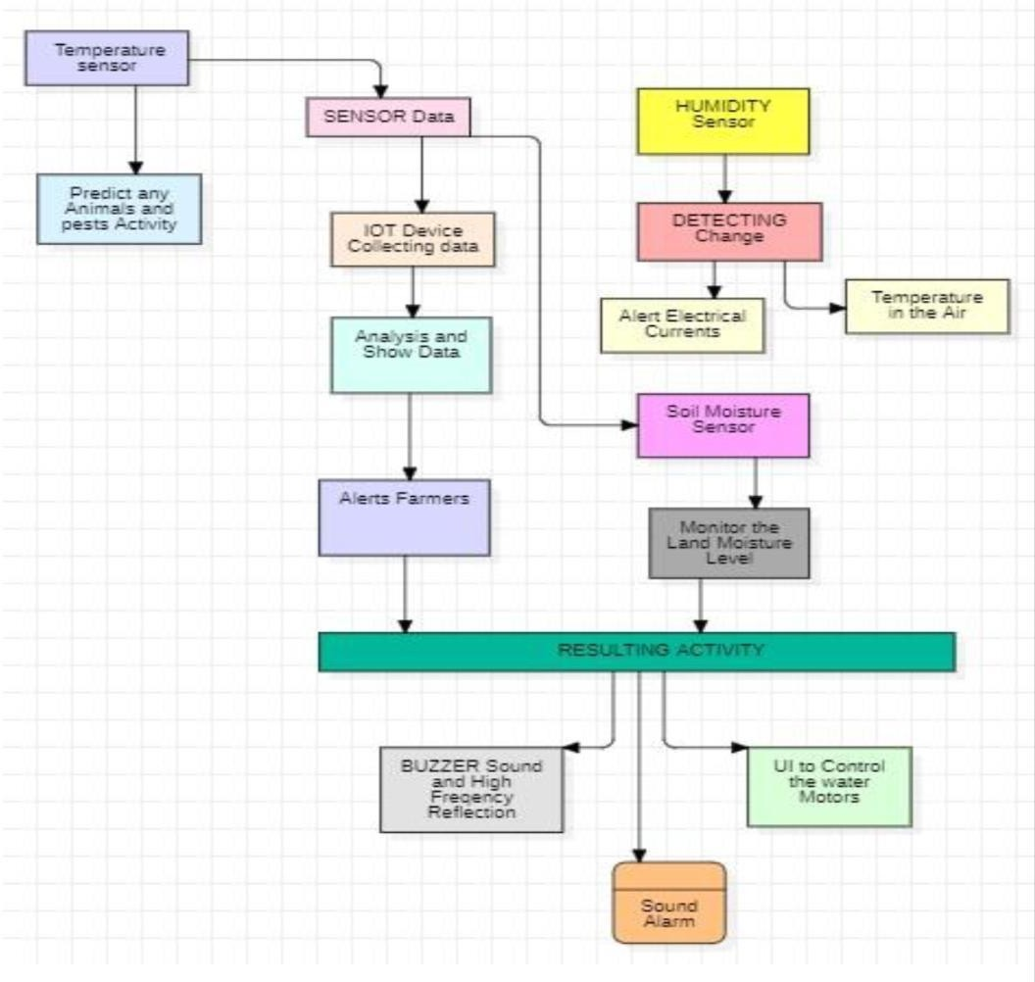

#### Solution Architecture:

Solution architecture is a complex process – with many sub-processes – that bridges the gap between business problems and technology solutions. Its goals are to :

* Find the best tech solution to solve existing business problems.
* Describe the structure, characteristics, behaviour, and other aspects of the software to project stakeholders.
* Define features, development phases, and solution requirements.
* Provide specifications according to which the solution is defined, managed, and delivered.
  1. **Solution Architecture Diagram:**

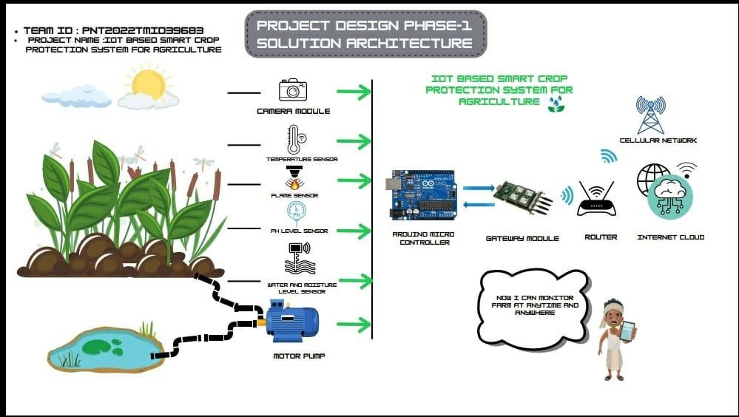

**6.1 Sprint Planning & Estimation**

|  |  |  |  |  |  |  |
| --- | --- | --- | --- | --- | --- | --- |
| **Sprint** | **Functional Requirement**  **(Epic)** | **User Story**  **Number** | **User Story / Task** | **Story Points** | **Priority** | **Team Members** |
| Sprint1 | Sensor Data(python script) | USN-1 | The Data of sensor which are feed to the  Raspberry pi .Here we are using python script to generate a random sensor data. | 3 | High | ISWARIYA A  (Team leader) |
| Sprint1 | Automation (python script) | USN-2 | Some activities are made to automation to overcome insufficient of labour force in the field. Hence that also included in  python script to implement automation | 5 | High | ISWARIYA A  (Team leader) |
| Sprint2 | IBM IOT platform | USN-3 | To  Send the raspberry pi data to IOT platform, we create an IBM IOT platform and connect the raspberry pi to the device created in IBM IOT. | 5 | High | JUSMITHA J S  (Team Member) |
| Sprint3 | Node RED service | USN-4 | To access the IBM IOT platform from external application or from external UI Node red service is established. | 5 | High | ROSHNI P S  (Team Member ) |
| Sprint3 | API Key | USN-5 | To protect the IBM IOT platform creating an API Key . |  | High | EBSIBA L C  (Team Member) |
| Sprint4 | User Application | USN-6 | To monitor and control the field sensors the User is provided with an User application created by MIT app inventor | 8 | High | ISWARIYA A  JUSMITHA J S  ROSHNI P S  EBSIBA L C |

Project Tracker, Velocity & Burndown Chart :

|  |  |  |  |  |  |  |
| --- | --- | --- | --- | --- | --- | --- |
| **Sprint** | **Total Story Points** | **Duration** | **Sprint Start Date** | **Sprint End Date (Planned)** | **Story Points Completed (as on**  **Planned End Date)** | **Sprint Release Date (Actual)** |
| Sprint-1 | 8 | 6 Days | 24  Oct 2022 | 29 Oct 2022 | 8 | 29 Oct 2022 |
| Sprint-2 | 5 | 6 Days | 31  Oct 2022 | 05 Nov 2022 | 5 | 05 Nov 2022 |
| Sprint-3 | 8 | 6 Days | 07  Nov 2022 | 12 Nov 2022 | 8 | 12 Nov 2022 |
| Sprint-4 | 8 | 6 Days | 14  Nov 2022 | 19 Nov 2022 | 8 | 19 Nov 2022 |

# Coding And Solutioning :

## Features

Feature 1: Detect the Temperature Feature 2: Detect the Humidity Feature 3: Detect the Moisture Feature 4: Detect the Animals **Codes:**

#### PYTHON CODE TO IBM:

import time import sys

import ibmiotf.application import ibmiotf.device import random

#Provide your IBM Watson Device Credentials organization = "iritj7"

deviceType = "abcd"

deviceId = "12345" authMethod = "token" authToken = "12345678"

# Initialize GPIO

def myCommandCallback(cmd):

print("Command received: %s" % cmd.data['command']) status=cmd.data['command']

if status=="lighton":

print ("led is on")

elif status == "lightoff":

print ("led is off") else :

print ("please send proper command")

try:

deviceOptions = {"org": organization, "type": deviceType, "id": deviceId, "auth-method": authMethod, "auth-token": authToken}

deviceCli = ibmiotf.device.Client(deviceOptions)

#..............................................

except Exception as e:

print("Caught exception connecting device: %s" % str(e)) sys.exit()

# Connect and send a datapoint "hello" with value "world" into the cloud as an event of type "greeting" 10 times

deviceCli.connect()

while True:

#Get Sensor Data from DHT11

temp=random.randint(90,110) Humid=random.randint(60,100) Moist=random.randint(20,100) Animal_dect=random.randint(1,20)

data = { 'temp' : temp, 'Humid': Humid, 'Moist' : Moist, 'Animal_dect' : Animal_dect }

#print data

def myOnPublishCallback():

print ("Published Temperature = %s C" % temp, "Humidity = %s %%"

% Humid, "to IBM Watson", "Published Moisture= %s" % Moist, "Published Animal detection = " , Animal_dect)

success = deviceCli.publishEvent("IoTSensor", "json", data, qos=0, on_publish=myOnPublishCallback)

if not success:

print("Not connected to IoTF") time.sleep(10)

deviceCli.commandCallback = myCommandCallback

# Disconnect the device and application from the cloud deviceCli.disconnect()

#### NODE RED CODE:

TEMPERATURE:

msg.payload=msg.payload.”temp” return msg;

HUMIDITY:

msg.payload=msg.payload.”Humid” return msg;

MOISTURE:

msg.payload=msg.payload.”Moist” return msg;

ANIMAL DETECTION:

msg.payload=msg.payload.”Animal_dect” return msg;

## TESTING:

#### TESTING :

* + - PYTHON CODE TO IBM
    - IoT SENSOR OUTPUT
    - IBM CLOUD TO NODE RED OUTPUT

#### User Acceptance Testing:

* 1. **Purpose of Document**

The purpose of this document is to briefly explain the test coverage and open issues of the [ProductName] project at the time of the release to User Acceptance Testing (UAT).

#### Defect Analysis

This report shows the number of resolved or closed bugs at each severity level, and how they were resolved

|  |  |  |  |  |  |
| --- | --- | --- | --- | --- | --- |
| **Resolution** | **Severity 1** | **Severity 2** | **Severity 3** | **Severity 4** | **Subtotal** |
| By Design | 10 | 4 | 2 | 3 | 20 |
| Duplicate | 1 | 0 | 3 | 0 | 4 |
| External | 2 | 3 | 0 | 1 | 6 |
| Fixed | 11 | 2 | 4 | 20 | 37 |
| Not Reproduced | 0 | 0 | 1 | 0 | 1 |
| Skipped | 0 | 0 | 1 | 1 | 2 |
| Won't Fix | 0 | 5 | 2 | 1 | 8 |
| Totals | 24 | 14 | 13 | 26 | 77 |

#### Test Case Analysis

This report shows the number of test cases that have passed, failed, and untested

|  |  |  |  |  |
| --- | --- | --- | --- | --- |
| **Section** | **Total Cases** | **Not Tested** | **Fail** | **Pass** |
| Print Engine | 7 | 0 | 0 | 7 |
| Client Application | 51 | 0 | 0 | 51 |
| Security | 2 | 0 | 0 | 2 |
| Outsource Shipping | 3 | 0 | 0 | 3 |
| Exception Reporting | 9 | 0 | 0 | 9 |
| Final Report Output | 4 | 0 | 0 | 4 |
| Version Control | 2 | 0 | 0 | 2 |

**9 RESULT**

MIT APP INVENTOR- TO DESIGN THE APP

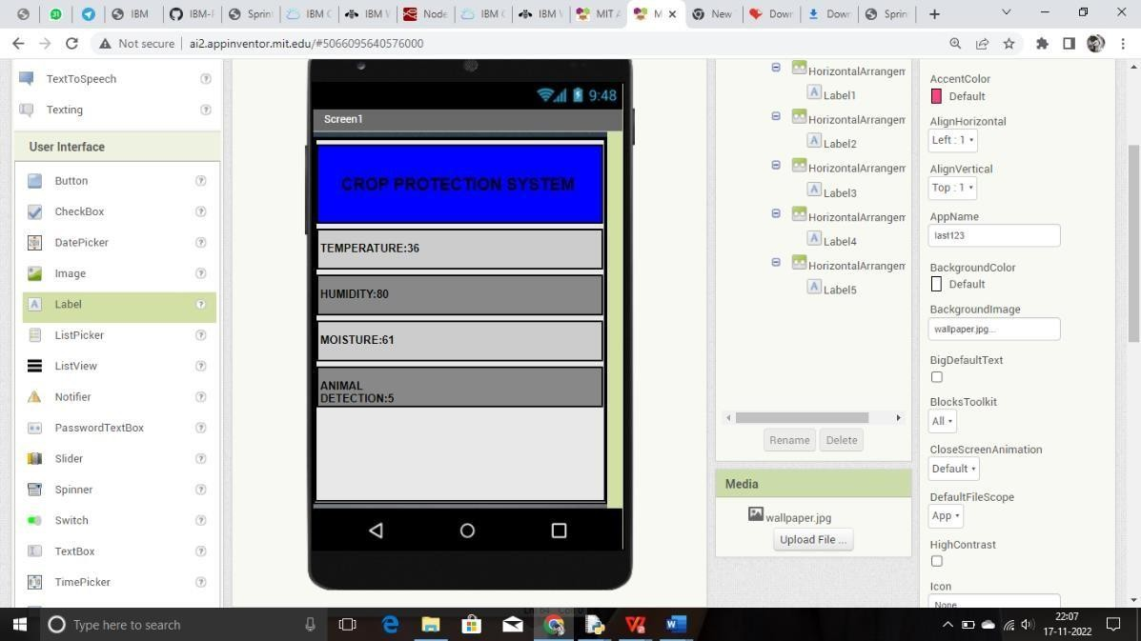

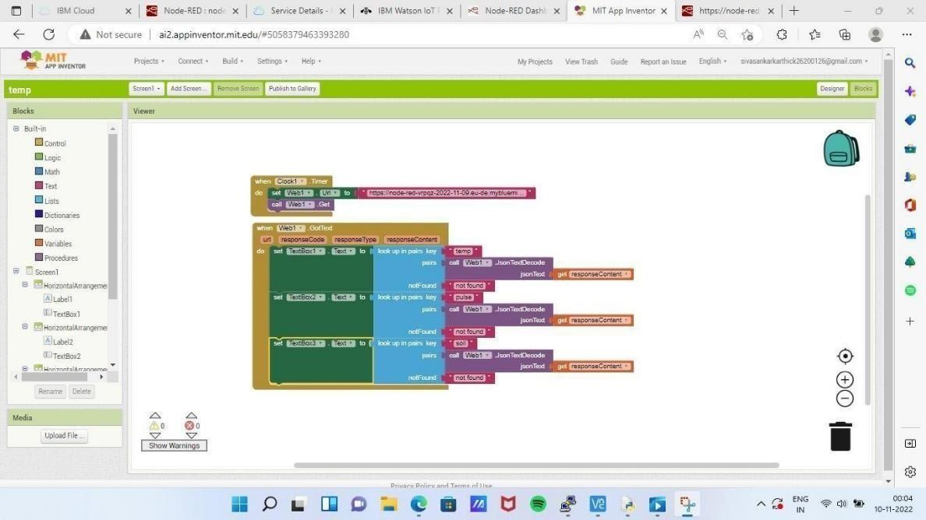

MIT AI2 COMPANION APP – TO DISPLAY THE OUTPUT VIA QR CODE

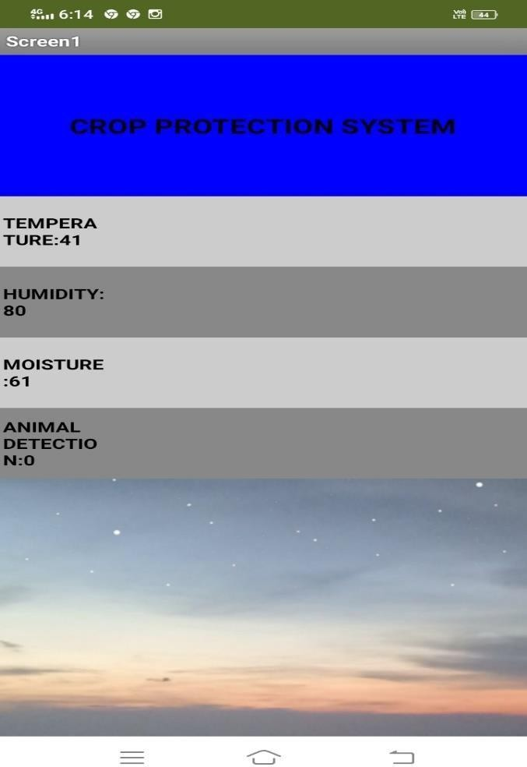

# ADVANTAGES :

* Farmers can monitor the health of farm animals closely, even if they are physically distant.
* Smart farming systems reduce waste, improve productivity and enable management of a greater number of resources through remote sensing.
* High reliance.
* Enhanced Security.

## DISADVANTAGES:

* + - Farms are located in remote areas and are far from access to the internet.
    - A farmer needs to have access to crop data reliably at any time from any location, so connection issues would cause an advanced monitoring system to be useless.
    - High Cost
    - Equipment needed to implement IoT in agriculture is expensive.

## APPLICATIONS:

* + - Monitoring the crop field with the help of sensors (light , humidity, temperature, soil moisture, etc.)
    - Automating the irrigation system
    - Soil Moisture Monitoring (including conductivity)

# CONCLUSION:

The problem of crop vandalization by wild animals and fire has become a major social problem in current time. It requires urgent attention as no effective solution exists till date for this problem.Thus, this project carries a great social relevance as it aims to address this problem. This project will help farmers in protecting their orchards and fields and save them from significant financial losses and will save them from the unproductive efforts that they endure for the protection their fields. This will also help them in achieving better crop yields thus leading to their economic well being.

# FUTURE SCOPE:

Study and analysis of the developed Crop protection systems for its cost

effectiveness with the development of Arduino based variable frequency Ultrasonic bird deterrent circuit. outline of the crop damage caused by a particular Wild animal if the behavioural features of the With the reduced cost in the smart phones.